National Research University Higher School of Economics Faculty of Computer Science

Programme ‘Master of Data Science’

MASTER’S THESIS

English title

Agent-based simulation of financial market

Russian title

Мультиагентное моделирование финансового рынка

Student: Usoltseva Liubov Igorevna

Supervisor: MOEX, HSE Lecturer Lukyanchenko Petr Pavlovich

Moscow, 2022

# Abstract

Agent-based models (ABM) are used for simulating complex systems and found its application in finance, microbiology, sociology and other fields of science. Modeling different types of [autonomous agents](https://en.wikipedia.org/wiki/Autonomous_agents) and its interaction inside ABM allows to understand the behavior of a whole system and find micro-scale agents parameters which affect on macro-scale state changes. This work is devoted to the creation of an ABM of financial market with four types of agents and investigation the patterns of system transition from one stationary state to another by an influence of synthetic price shock.

Source code of the project is available on GitHub: https://github.com/Liucinda/ABM_clustering

Contents

Abstract 2

1. Introduction 4

1.1 Motivation 4

1.2 Structure of the work 4

2. Financial market and trading algorithms 5

3. Agent-based modeling 6

4. Model architecture 8

3.1 Input parameters 9

3.2 Procedure 11

3.3 Running module 11

4.1 Market maker algorithm 14

4.2 Noise traders’ behavior 15

4.3 High frequency traders algorithm 15

4.4 Long-term strategy agent’s algorithm 16

4.5 Launch modes 16

5. Sensitivity analysis 17

6. Time series clustering 21

6.1 K-Means clustering 25

6.2 Clustering using principal component analysis 29

6.3 MiniSom clustering 30

7. Conclusion 32

8. Future work 32

9. References 33

Appendix 36

# Introduction

## 1.1 Motivation

Agent-based modeling (ABM) is commonly used for simulations of complex system behaviors in different scientific domains. Such modeling is based on describing several types of agents, its parameters and interaction rules between each other depending on their states and system properties at every moment. In many cases, ABM are used to study behaviors that occurs in the system in general and on micro level with a predefined set-up of rules for different types of agents.

The purpose of this work is to use ABM simulation to analyze behavior of the financial market and its transition between states with various endogenous and exogenous variables of the model.

## 1.2 Structure of the work

Current multi-agent model was created by using Mesa framework (<https://mesa.readthedocs.io/en/latest/overview.html>) and contains four types of agents: noise traders, high-frequency traders, long-term strategy traders and market makers. The interaction between the agents was carried out with the assumption that all sell or buy offers are made through market makers.

Diverse behavior at the system level showed that the set of rules in the multi-agent model is sufficient to generate the emerging behavior.

The sensitivity of the model to certain parameters was also investigated using multiple modeling and the most important parameters of the system were determined using ML methods.

Using Monte Carlo method sets of suitable parameters for model natural behavior was found. Then the patterns of transition with artificial price shock in the stock market were investigated.

# Financial market and trading algorithms

The scientific community has shown an active interest in developing models of financial markets that would be realistic, practical and manageable. There are four main directions of developing in literature: theoretical equilibrium models from financial economics, statistical order book models from econometrics, stochastic models from the mathematical finance community, and agent models (ABM) from complexity science.[3]

While it is not too difficult to observe the actions taken by market participants, it is more problematic to determine what controls these actions, for example, when, how and why participants perform these actions, how they determine the parameters of orders. There are many factors that influence on the actions of traders, including their roles in the market, the structure of the market itself and their individual characteristics. The problems of understanding the dynamics of the market are associated with the presence of the following aspects: the mechanism of stock price determination and trader’s decision-making mechanisms. The first one is primarily related to the organization of the financial market, and the second to the behavior of market participants. Considering the involvement of market participants both in placing orders and in their execution, these two aspects are closely related to each other.

Trading and structure of the markets are widely studied in the literature on market’s microstructure. The corresponding articles include description of trading rules, nature of pricing formation, entry, exit and determinants of market structure as well as possible outcomes of trader’s strategies. [4]

Typically, financial economics models are based on the idea that liquidity arises as liquidity providers try to benefit and is spent during a transaction. In such models, the volume of hidden liquidity reflects the level of sustainability. Among various models of markets, there are examples with finite levels of stability in equilibrium, which depend mainly on the characteristics of market participants. [5, 6] As well as partial equilibrium models using the dynamics of the portfolio of limit orders as a given.

Sometimes the authors of models suggest an approach with discrete orders and more general dynamics, but there are also examples with a general and continuous book of limit orders. [8, 9]

Usually, for the balanced operation of the model, the sets of possible strategies for placing orders are very limited. Moreover, both the order size and the types of strategies can be limited, for example, only one-shot strategies are presented in the model. [10, 11] Despite the fact that such assumptions make it possible to more accurately describe the tradeoffs presented by market participants, this is still a consequence of unrealistic assumptions and simplifications. The practical applicability of such models is very limited and it is even more difficult to estimate the parameters of the model based on real data. [12] At the same time, descriptive statistical models usually correspond closely to the data, but often lack economic rigor and also include the adjustment of several free parameters. [13] Consequently, their practical expediency is doubtful.

Stochastic order book models are characterized by the representation of aggregate order flows by a random process, usually a Poisson process. They try to balance descriptive power and analytical accuracy but ignore important and complex interactions between market participants and cannot explain many emerging phenomena. [14] Thus, for a better understanding of market processes, a more complicated approach to modeling is required, that allows to observe the processes at the micro and macro level.

# Agent-based modeling

Agent-based modeling is widely used technique to emulate a complex system behavior and interaction between different agents. Let us define the following constraints for determining multi-agent system. Any system that consists of individual components acting in accordance with its own set of rules is multicomponent. The transition of an individual component from one state to another occurs when certain conditions are satisfied. This condition may depend both on the state of the agent itself and on the state of other agents or the whole system. If all the necessary conditions are met, the agent makes the transition from the primary state to the new one. In the multi-agent model, various types of components (agents or objects) are defined, and each type makes transitions between states according to its own rules. In such a system, several agents of each type are usually created. Agents of each type behave identically under the same conditions.[1] Compared to the traditional mathematical model, agent-based modeling is easier to synthesize using a detailed description of the parameters and behavior of each type of agent. This method simplifies the investigation, testing and debugging of agent interaction and system operation. It also simplifies the collection of information about agents and the system itself.

Financial markets are a complex multicomponent system in which a number of individual agents constantly interact.

Several classical analytical models were developed to study and explain the behavior of financial markets, but the complexity of the financial environment stimulated modeling using agent-based architectures. The authors argue that multi-agent modeling provides a better understanding of how observable properties in real markets arise as a result of interaction between agents.

A large number of system parameters is both the advantages and disadvantages of agent models of financial markets, the impact of which is highly difficult to assess. Therefore, the study also analyses the influence of the system parameters on changing price trend during trading sessions.

# Model architecture

Multiagent simulation was implemented with application of modular framework Mesa (<https://mesa.readthedocs.io/en/latest/overview.html>). Each type of agents has its start parameters, like cash and wealth, and thresholds, that restrict its behavior (such as hard line of selling/buying for market makers) or specify periods for calculating metrics defining agent’s action. A detailed description of the full set of parameters is provided below. Bidding in the model takes place in stages (like rounds). Within one round all agents except market makers are choosing its intension – to buy, to sell or to do nothing. Also, they define price and amount of the corresponding buy/sell order. Some of agents make a decision by taking into account other orders, so agents can be influenced by decisions of its neighbors.

Collected orders are submitted to market makers in accordance with their profitability. After that the process of selecting the contractor for each corresponding order is being undertaken. Market makers have its own restrictions as price thresholds and hard lines of buying and selling during one trading session. The schematic description of the process is presented in Figure 1.

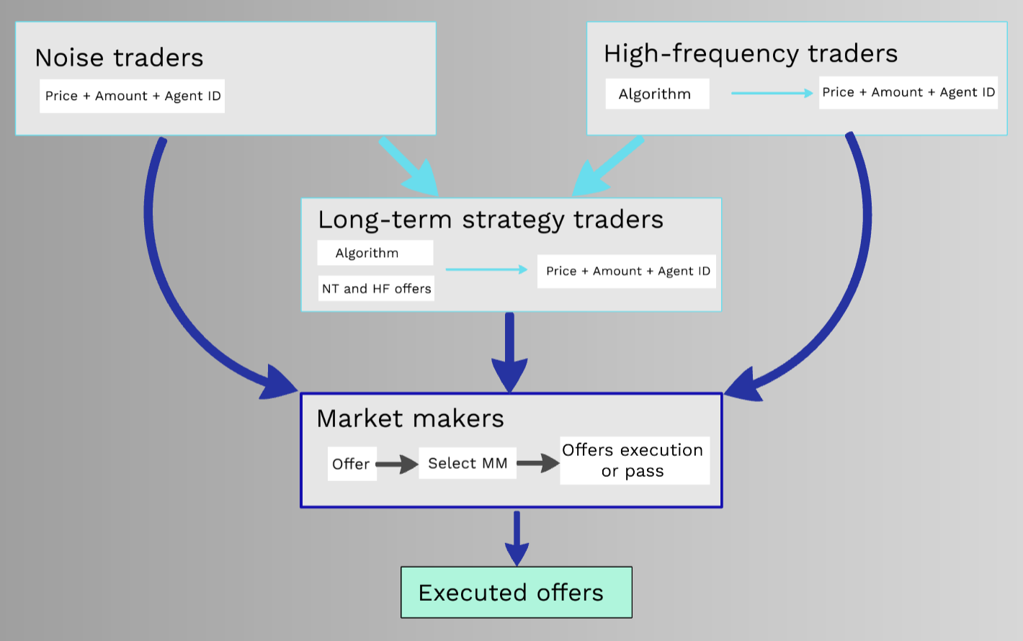

**Figure 1.** Schematic diagramof the processes of one trading session

## 3.1 Input parameters

The starting parameters describe the initial state of the market, number of agents of each type, their starting portfolio and existing restrictions.

Market maker’s initial parameters are presented below:

* market_maker_cash – cash of individual agent;
* market_maker_wealth – initial wealth;
* mm_type1, mm_type2 mm_type3 – number of the market makers with appropriate type of threshold;
* mm_spread_width_type1, mm_spread_width_type2, mm_spread_width_type3 – three types of price thresholds are used for selecting offers to execute;
* mm_max_wealth – number of shares that is a signal to stop buying shares;
* mm_hard_line_sell – number of shares which can be sold by initial market maker during one trading session;
* mm_hard_line_buy - number of shares which can be bought by initial market maker during one trading session.

Noise traders’ initial parameters:

* noise_traders – the number of agents of type noise traders;
* noise_traders_cash – initial cash of noise trader;
* noise_traders_wealth – initial wealth of noise trader.

Long-term strategy traders’ initial parameters:

* long_term_type1, long_term_type2, long_term_type3 – the number of long-term strategy traders of trading algorithm 1, 2 and 3 accordingly;
* long_term_cash – initial cash of long-term strategy traders;
* long_term_wealth – initial wealth of long-term strategy traders.

High frequency traders’ initial parameters:

* high_freq – the number of high-frequency traders;
* high_freq_cash, high_freq_wealth – initial cash and wealth of high frequency traders;
* high_freq_lag – the width of the estimated price window;
* high_freq_threshold – the price changing signal for buying/selling shares.

Global parameters:

* start_price – the price of the first round of trading;
* shock_step – the order of trading session when artificial price shock will be implemented;
* shock_price_change – the price coefficient which will be implemented on shock_step trading session.

Global variables:

* price – current price on the market;
* volume – trading volume for last trading session;
* step_count – number of steps (trading sessions) to be done.

## 3.2 Procedure

To run the model, it should be initialized with default or user’s parameters and function run_model have to be called with the value of step count. This causes processes of creating agents and starting trading sessions.

Each agent type has implemented step method which calls every trading session: this is the function for making a decision to buy, to sell or to do nothing for agents-traders and to execute order for market maker.

Also, agents have procedure for detecting signs of bankruptcy, agent which went bankrupt will not participate in trading session anymore.

The ABM can work in two modes: return pattern of price changing with artificial shock or return evolution of Bollinger Bands Width (BBW) during trading sessions.

## 3.3 Running module

Helper class for running the model and save the results to CSV file was implemented. It allows to run the model with different set of parameters by a given number of iterations and at the end of the process CSV file is created with recorded initial parameters and results of trading sessions.

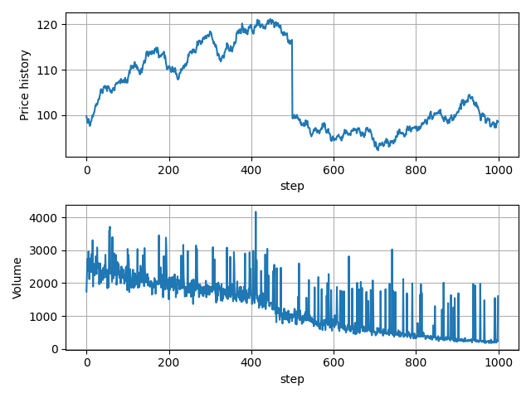

**Figure 2.** The example of model run (evolution of price history and trading volume) through 1000 trading sessions (steps) with shock price decreasing by 15% on step 500.

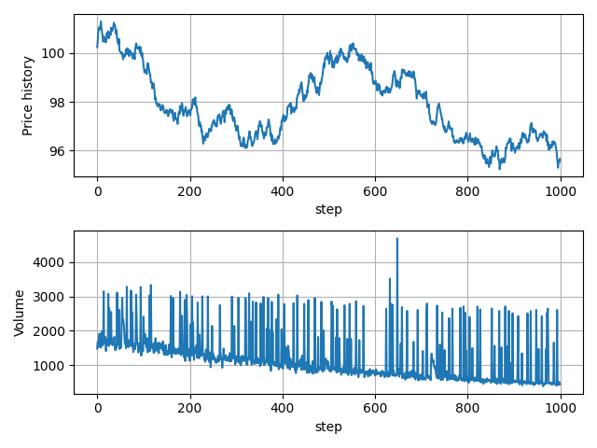

**Figure 3.** The example of model run (evolution of price history and trading volume) through 1000 trading sessions (steps) without any shock.

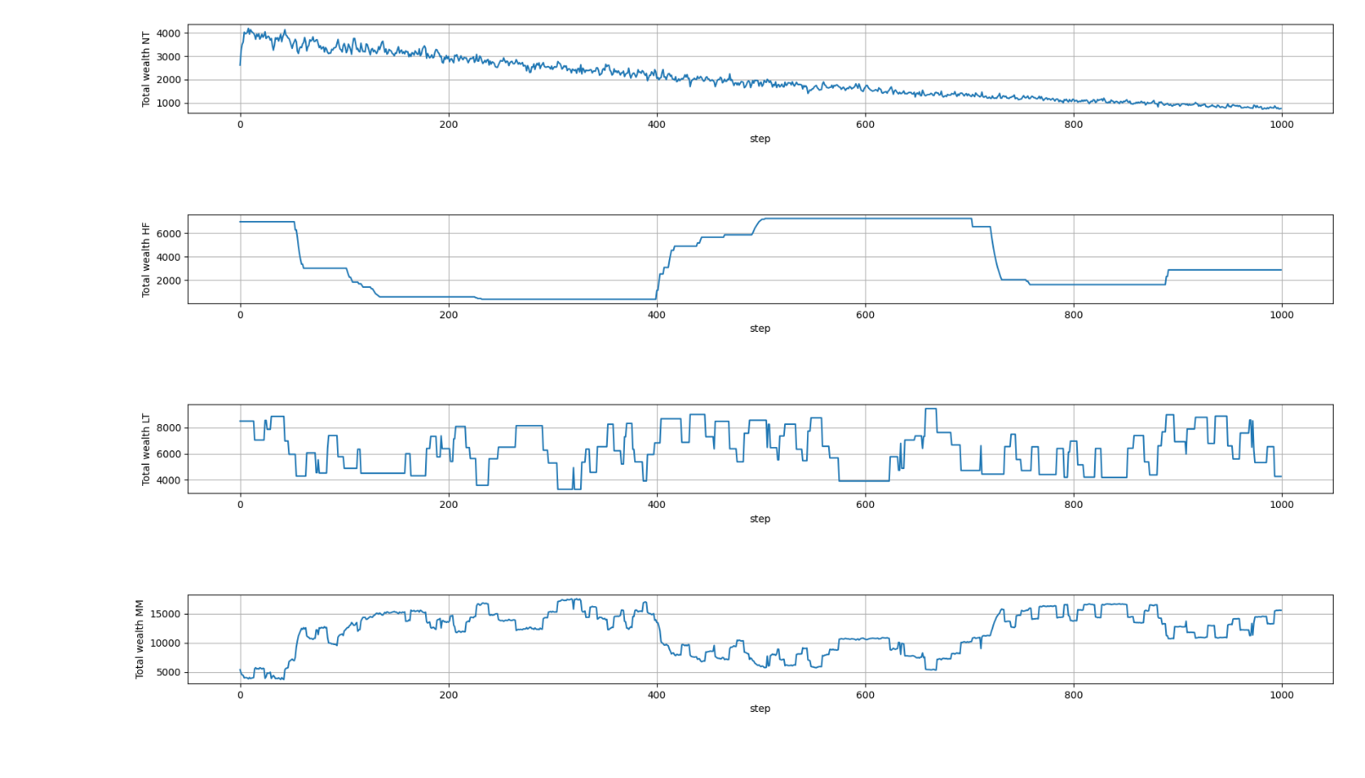

**Figure 3.** The example of change in the number of Noise, High-frequency, Long-term strategy traders’ and Market makers’ shares through 1000 trading sessions (steps) without any shock.

## 4.1 Market maker algorithm

The assumption of this ABM is that market makers do not post orders, but only have access to orders of other agents and have to choose which of that will be executed. So, the process is the following: market makers obtain an order list, then selective process of orders is initiated where the matching orders are been executed consistently. Firstly, the ability of a particular market maker to execute the specific buy or sell order is being verified. If the order finds its executer the trade is made so the iteration stopped. Or another issue, if there is no market maker that can execute the current order, this order will pass unexecuted. Market makers process a list of orders in a descending order of its profitability.

To define the ability of market maker to execute the order the model check is made:

* whether the market maker possesses enough cash or wealth;
* whether the hard lines of selling or buying are exceeded;
* whether the maximum value of market maker’s wealth is reached.

After that there is also a check for price threshold, which current market maker should stick to.

## 4.2 Noise traders’ behavior

This type of traders chooses randomly its intension to buy or sell shares except stages when it has no cash or wealth. The amount to trade is also chosen randomly and the price for the order is defined using Gaussian distribution, where the current price is represented as a mean with a small variance.

These agents present market participants who operate without any professional advice or technical and fundamental analysis.

## 4.3 High frequency traders’ algorithm

This type of agents invests based on the belief that price changes have inertia a strategy is known to be widely used. [7] They used а momentum strategy which implies taking a long position when prices have been recently rising and a short position when they have recently been falling. This action is based on calculating a rate of change (ROC) to detect corresponding moments:

$$roc(t)= \frac{p(t)-p(t-nr)}{p(t-nr)}$$

, where p(t) – current price and p(t-nr) is the price high_freq_lag steps before. When this value is greater than specified threshold high_freq_threshold, this type of agents attempts to buy stocks of a value proportional to the strength of the momentum. Otherwise, if the momentum is less than -high_freq_threshold, they try to sell.

## 4.4 Long-term strategy agent’s algorithm

Another type of intelligent traders uses indicators called ‘death cross’ and ‘golden cross’. There are three types of long-term investors which differ in calculation periods for moving averages. The first group evaluate 5-days and 15-days moving averages, the second group – 10-days and 30-days and the third – 20-days and 60-days.

A golden cross is a chart pattern that occurs when short-term moving average crossing above a long-term moving average. For each agent of this type golden cross indicates that the price may be starting to rise, so it is a buy signal.

A death cross occurs if short-term moving average crosses below long-term moving average, means that price is potentially starting a new downtrend, so selling shares is preferred.

Long-term strategy agents use average price of offers from other types of agents.

## 4.5 Launch modes

After the model was implemented and debagged it was necessary to classify the results of model launches with different set of parameters and determine those that most affect the dynamics of the artificial market. It also was necessary for selecting specific parameters to observe some natural shock on the market.

So, there are two modes of model launching: the first one use classification based on price trends before and after shock and contain nine classes:   
1) price decreasing -- shock -- price increasing  
2) price increasing –> shock –> price increasing  
3) price decreasing –> shock –> price decreasing  
4) price increasing –> shock –> price decreasing  
5) stable price –> shock –> price decreasing  
6) stable price –> shock –> price increasing  
7) stable price –> shock –> stable price  
8) price decreasing –> shock –> stable price  
9) price increasing –> shock –> stable price

In this mode the model is supposed to run several times (twenty in this analysis) and for every set of parameters return the most frequent variation of the price change. At the end parameters values and the most frequent pattern of price trend for each parameters set are collected in the CSV file.

The second mode assumes research of one set of parameters with or without artificial shock implemented. For every run in this mode Bollinger Bands Width is collected for every five steps (trading rounds). As a result, the CSV file with parameters and BBW values recorded.

# Sensitivity analysis

For better understanding the impact of each parameter at market dynamics models with different set of parameters were run with artificial shock implemented on some step out of 1000. After collecting the data some ML models were applied in order to investigate the predictability of price trend pattern and find the most influential parameters. The literature review [15, 16, 17] showed that Neural Network, Gradient Boosted Trees and Gaussian Process models show the best results. In order to find most important parameters a few models were used, including CatBoost Classifier that uses gradient boosting on decision trees. And this model shows the best scores in this experiment. The data was firstly normalized using the z-score. The formula for z-score is shown below:

z = (x - u) / s

where u is the mean of the training samples and s is the standard deviation of the training samples.

The result score is shown below:

Accuracy: 0.75667

F-score: 0.73392

Precision: 0.74501

Recall: 0.75667

Accuracy (balanced): 0.37555

MCC: 0.62399

Соnfusion matrix:

|  | **y = 1** | **y = 2** | **y = 3** | **y = 4** | **y = 5** | **y = 6** | **y = 7** | **y = 8** | **y = 9** |
| --- | --- | --- | --- | --- | --- | --- | --- | --- | --- |
| **a(x) = 1** | 0 | 0 | 0 | 0 | 0 | 0 | 0 | 0 | 0 |
| **a(x) = 2** | 0 | 3 | 0 | 0 | 0 | 0 | 0 | 0 | 1 |
| **a(x) = 3** | 0 | 0 | 105 | 0 | 1 | 1 | 2 | 17 | 0 |
| **a(x) = 4** | 0 | 0 | 0 | 1 | 0 | 1 | 0 | 0 | 0 |
| **a(x) = 5** | 0 | 0 | 0 | 0 | 0 | 0 | 0 | 0 | 0 |
| **a(x) = 6** | 0 | 0 | 0 | 1 | 0 | 12 | 0 | 2 | 1 |
| **a(x) = 7** | 1 | 11 | 11 | 4 | 3 | 22 | 436 | 43 | 22 |
| **a(x) = 8** | 0 | 0 | 29 | 0 | 0 | 1 | 18 | 78 | 2 |
| **a(x) = 9** | 0 | 12 | 0 | 5 | 1 | 2 | 5 | 0 | 46 |

Table 1. Confusion matrix (a result of CatBoost classification)

The data is imbalanced and the most frequent pattern is №7 – ≈ 51% (stable price before and after shock). The results of predicting the outcome of the ABM are not as good as in articles analyzed for this study and there are several reasons for that: imbalanced data, large number of classes and not as large dataset (3000 unique rows). However, it is enough for selecting the most important parameters of the model. The table with features importance is presented below:

|  | **Feature Id** | **Importances** | **Parameter_name** |
| --- | --- | --- | --- |
| **0** | 12 | 21.790157 | mm_hard_line_sell |
| **1** | 13 | 16.217727 | mm_hard_line_buy |
| **2** | 0 | 8.431319 | noise_traders |
| **3** | 1 | 5.174231 | noise_traders_cash |
| **4** | 8 | 4.887022 | mm_spread_width_type1 |
| **5** | 2 | 4.343135 | noise_traders_wealth |
| **6** | 7 | 3.652275 | mm_type3 |
| **7** | 6 | 3.346988 | mm_type2 |
| **8** | 10 | 3.300242 | mm_spread_width_type3 |
| **9** | 9 | 2.881963 | mm_spread_width_type2 |
| **10** | 3 | 2.738477 | market_maker_cash |
| **11** | 24 | 2.328232 | shock_step |
| **12** | 25 | 2.303641 | shock_price_change |
| **13** | 5 | 2.257173 | mm_type1 |
| **14** | 20 | 1.807781 | high_freq_cash |
| **15** | 11 | 1.706769 | mm_max_wealth |
| **16** | 22 | 1.644187 | high_freq_lag |
| **17** | 21 | 1.508642 | high_freq_wealth |
| **18** | 14 | 1.465045 | long_term_type1 |
| **19** | 23 | 1.449576 | high_freq_threshold |
| **20** | 18 | 1.385738 | long_term_wealth |
| **21** | 16 | 1.326724 | long_term_type3 |
| **22** | 17 | 1.314475 | long_term_cash |
| **23** | 19 | 1.235500 | high_freq |
| **24** | 4 | 1.123057 | market_maker_wealth |
| **25** | 15 | 0.379924 | long_term_type2 |

Table 2. Feature importance (a result of CatBoost classification)

As we can see, the most powerful parameters are characteristics of Market Makers – hard lines of buying and selling, which are the constrains of the model. By changing these two variables various models’ behaviors can be observed.

# Time series clustering

Clustering is a widely used technique consisting of grouping objects (points, datasets or time-series) by maximizing its similarities within the same group for data analysis and investigating the structure of unlabeled data. Clustering of time-series is a special challenge. This allows us to define the pattern of data changes over time and discover various mechanisms of system behavior.

The crucial part of this work was devoted to the Bollinger bands width (BBW) series clustering after artificial shock implemented on the market. It is assumed that there are model transition patterns to a new stable state after implementing of an artificial price shock on the market.

There are two main clustering approach: the first one is focused on trying to present time-series in a lower dimension and conventional clustering algorithms usage, and the second one is based on different approaches to distance measurement on raw data. [18]

The first method is used to represent data in modified form with lower dimensionality. If there are two series similar in the original space, their representation should be also similar in the transformation space.

For the second approach the most common method for similarity measure are Euclidean distance and Dynamic time warping. These methods were applied in this analysis as well.

For this analysis the following set of model’ parameters was chosen:

noise_traders = 200  
noise_traders_cash = 3000  
noise_traders_wealth = 10  
  
market_maker_cash = 200000  
market_maker_wealth = 1000  
mm_type1 = 2  
mm_type2 = 3  
mm_type3 = 1  
mm_spread_width_type1 = 0.005  
mm_spread_width_type2 = 0.01  
mm_spread_width_type3 = 0.01  
mm_max_wealth = 10000  
mm_hard_line_sell = 400  
mm_hard_line_buy = 400  
  
long_term_type1 = 50  
long_term_type2 = 20  
long_term_type3 = 100  
long_term_cash = 3000  
long_term_wealth = 50  
  
high_freq = 70  
high_freq_cash = 1000  
high_freq_wealth = 100  
high_freq_lag = 20  
high_freq_threshold = 0.01  
  
start_price = 100.0  
shock_step = 300  
shock_price_change = 0.9

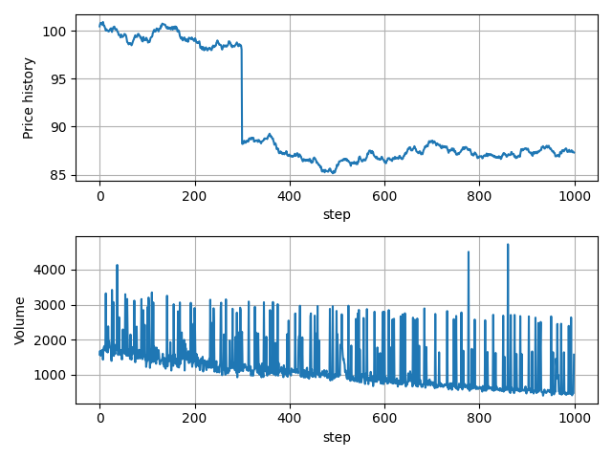

**Figure 4.** An example of shock implementation on step №300.

For clustering analysis, the data of 500 runs was collected with the same set of parameters. From each fifth step the BBW value was calculated and collected. As a result, we got 500 time-series which describe evolution of selected metric after the artificial shock took place.

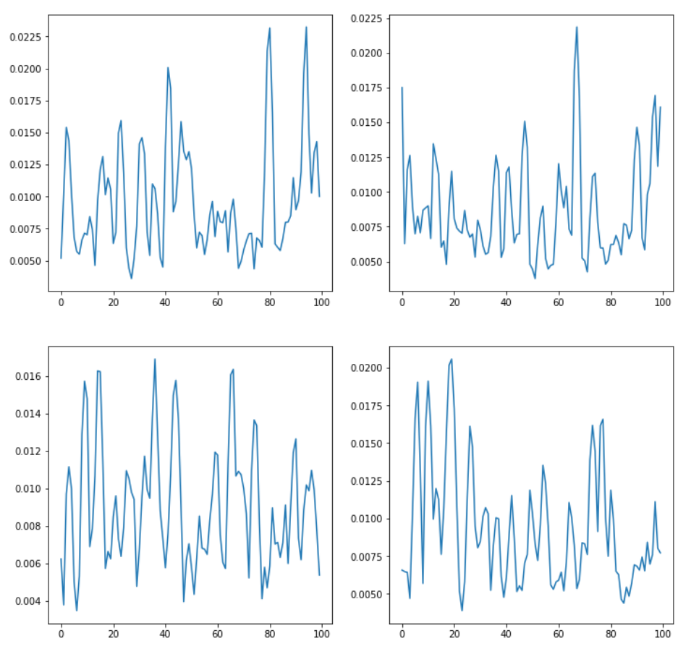

**Figure 5.** Time-series of BBW without smoothing

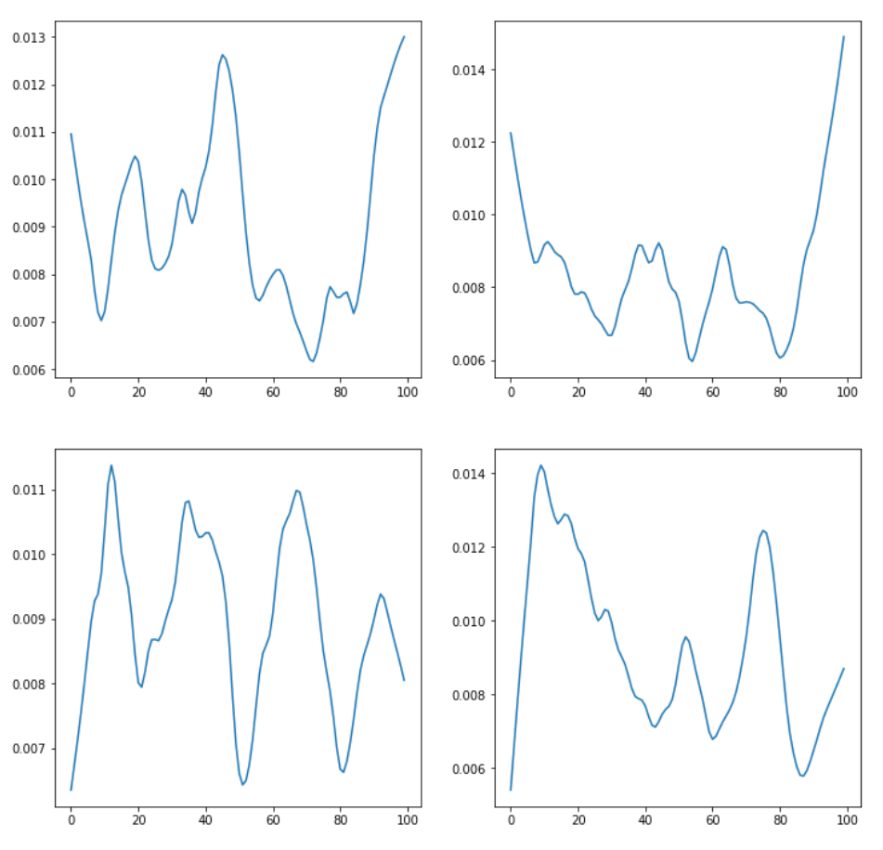

**Figure 6.** Example of smoothing time-series with statsmodels.nonparametric.smoothers_lowess.lowess with frac=0.15

For reducing noise in data, the locally weighted scatterplot smoothing method from statsmodels library was implemented. Also, standard scaling was used before clustering.

## 6.1 K-Means clustering

K-means clustering with three type of metrics – Euclidean distance, DTW and soft-DTW shows very noisy clusters on the selected time-series.

Examples of K-means clustering with Euclidean distance metric are shown below, the full results are presented in the Appendix.

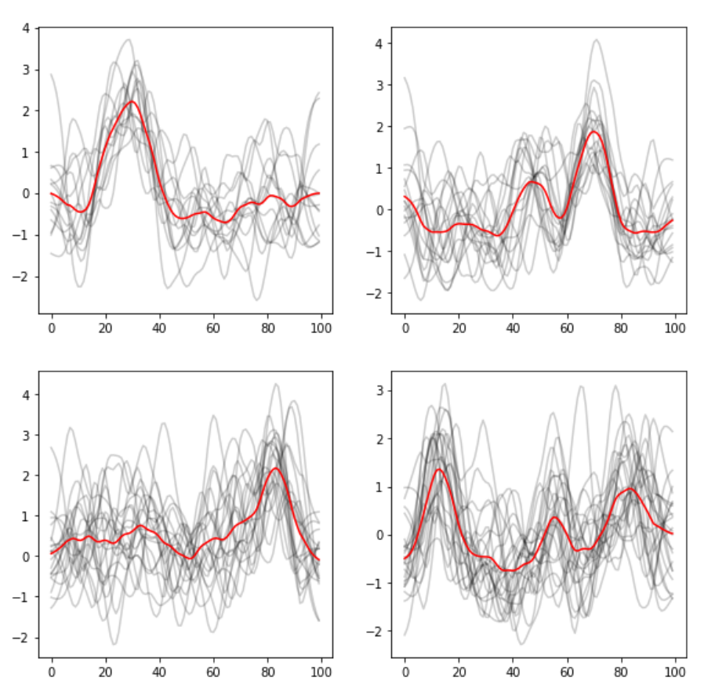

**Figure 7.** Clusters example for k-means with Euclidean distance metric

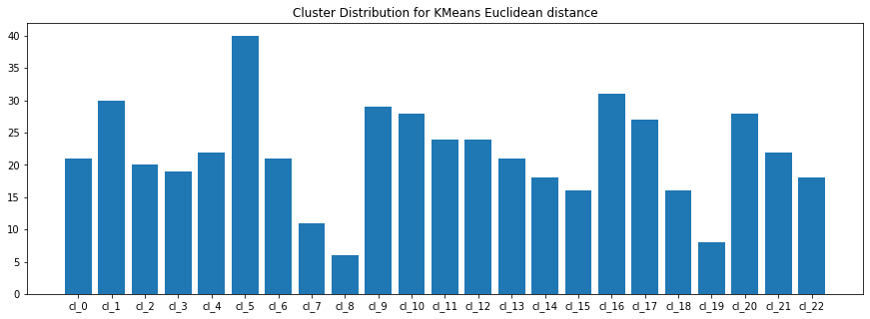

**Figure 8.** Clusters distribution for k-means with Euclidean distance metric

This method shows pretty good results especially for some clusters, such as № 0, 8, 19.

The next experiment clustering was made by k-means model with dynamic time warping metric which often shows better accuracy than Euclidean distance. The full results are shown in the Appendix.

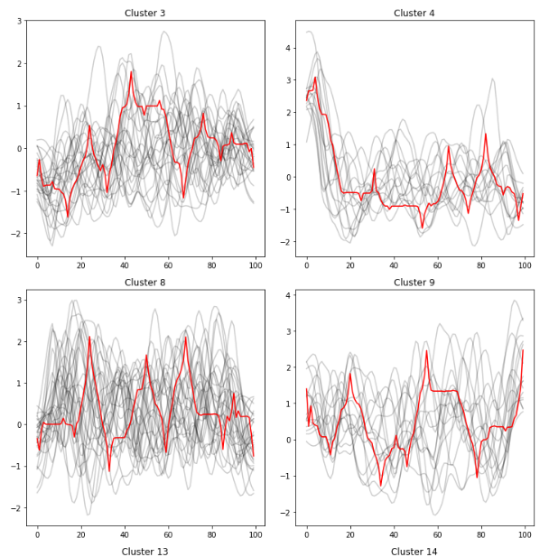

**Figure 9.** Example of clusters for k-means with DTW metric

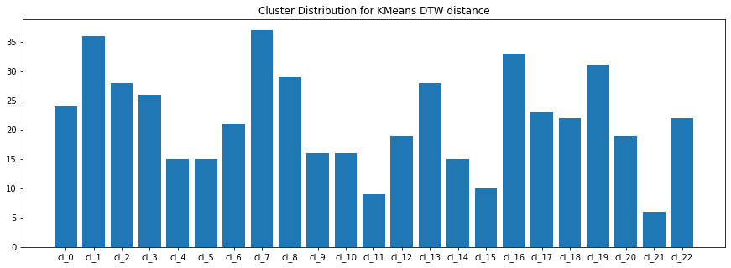

**Figure 10.** Distribution by clusters for k-means with DTW metric

The results look noisy and unstable for the current dataset. No delineated clusters were highlighted. Soft-DTW metrics also shows not good results on this application. Example of clusters below.

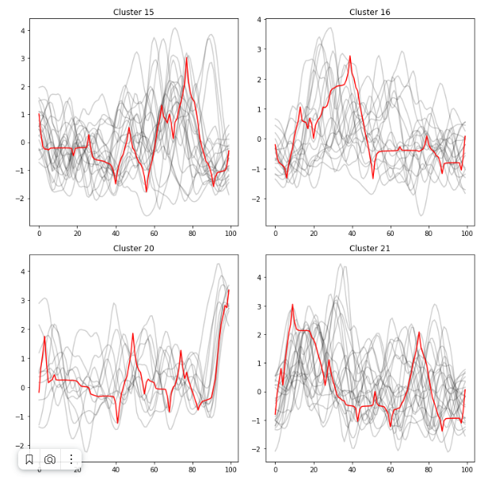

**Figure 11.** Example of clusters for k-means with Soft-DTW metric

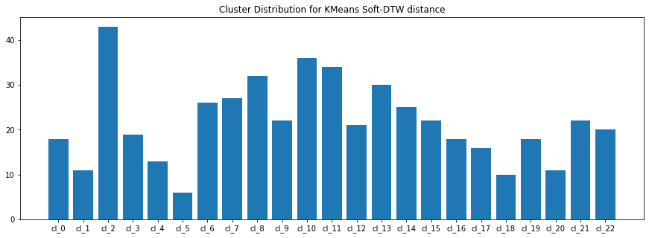

**Figure 12.** Distribution by clusters for k-means with Soft-DTW metrics

Clusters look the same as in previous example, so this metric must be admitted as ineffective.

## 6.2 Clustering using principal component analysis

Principal component analysis was used to implement K-means model and DBSCAN for clustering data with lower dimensionalities. For the first experiment (K-means) along with more delineated clusters (12, 17) we can see also highly noisy ones (16). Moreover, the most qualitative clusters contain the least amount of time-series.

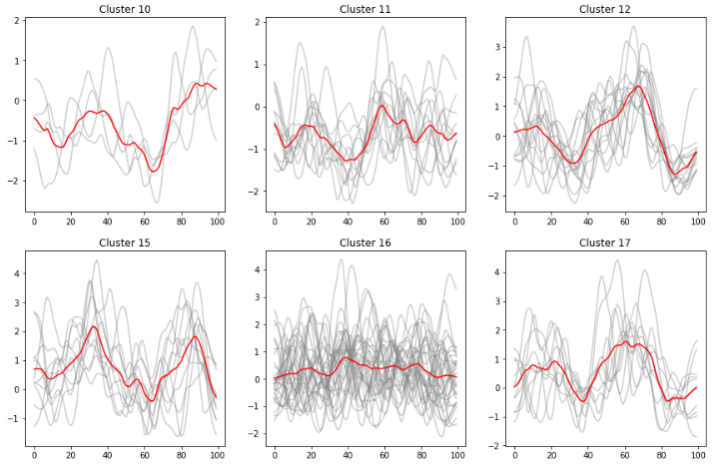

**Figure 13.** Example of clusters for PCA + k-means Euclidean distance metric

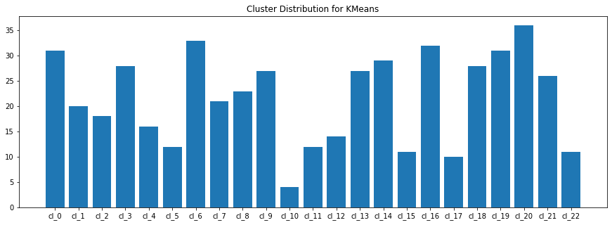

**Figure 14.** Distribution by clusters for PCA + k-means Euclidean distance metric

By next step, the DBSCAN model was implemented on data with reduced dimensionalities. In results we can see 8 delineated clusters and 1 noise cluster with the remaining time-series.

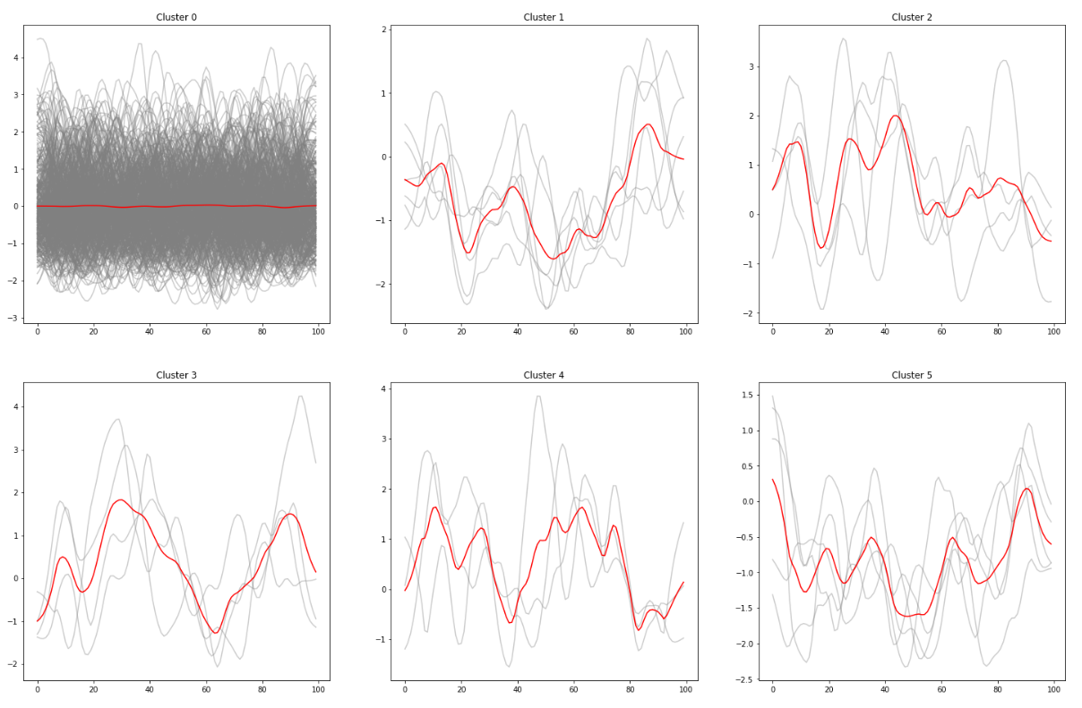

**Figure 15.** Example of clusters for PCA + DBSCAN

## 6.3 MiniSom clustering

MiniSom is an implementation of artificial neural network model Self Organizing Maps (SOM) and it is able to convert complex, nonlinear statistical relationships between high-dimensional data items into simple geometric relationships on a low-dimensional display. It shows the best clustering for current time-series compared with other implemented models.

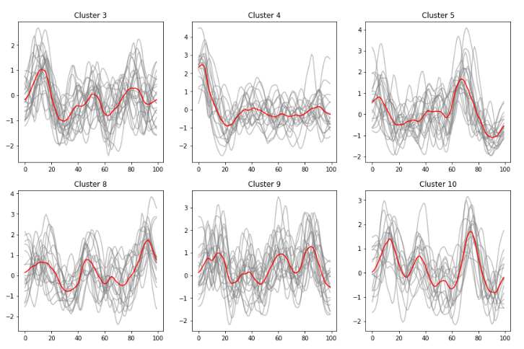

**Figure 16.** Examples of MiniSOM clustering

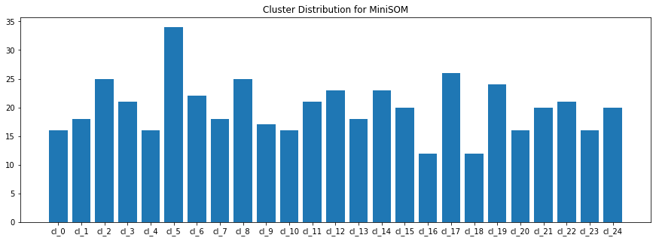

**Figure 17.** Distribution by clusters for MiniSOM

The MiniSOM shows the most homogeneous clusters with uniform distribution. Additionally, sufficient quality of clustering goes with fast training comparable with others implemented models for clustering.

# 7. Conclusion

Current research was devoted to build and analyze the agent-based model of financial market with four types of agents. The balance of agents and their interaction are set by 28 input parameters of ABM. The most significant are the parameters that limit the behavior of market makers such as hard lines of buying and selling.

The investigation of the ABM response on the artificial shock values of Bollinger bands width were analyzed to detect common patterns of transition to some new stable state. The best results of clustering were observed with implementation of MiniSom model, which is the realization of Self Organizing Maps – a type of Artificial Neural Network. This model shows the most delineated clusters for BBW datasets.

# 8. Future work

Due to the high resource requirements for ABM operation and collecting big data it is common approach to create a surrogate model by training ML or Neural network models. So current ABM can be used for collecting data for creating its surrogate and fast selecting necessary parameters for finding anomalies.

Along with that it is required to investigate another market metrics for deeper understanding agents’ behavior and market reaction on dramatic price decrease. This research can help to better understand the market dynamics and ways of transferring behind stationary states.

# 9. References

[1] Chih-Chun Chen, Sylvia B. Nagl, and Christopher D. Clack (2008) A Method for Validating and Discovering Associations between Multi-level Emergent Behaviours in Agent-Based Simulations DOI: 10.1007/978-3-540-78582-8_1

[2] Mohamed Amine Souissi, Khalid Bensaid, Rachid Ellaia (2018) Multi-agent modeling and simulation of a stock market DOI: 10.21511/imfi.15(4).2018.10

[3] Frank McGroarty Ash Booth Enrico Gerding V. L. Raju Chinthalapati (2019) High frequency trading strategies, market fragility and price spikes: an agent-based model perspective <https://doi.org/10.1007/s10479-018-3019-4>

[4] Harris, L. (2003), Trading and Exchanges: Market Microstructure for Practitioners, Oxford University Press.

[5] Goettler, R. L., Parlour, C. A., & Rajan, U. (2005) Equilibrium in a dynamic limit order market  <https://doi.org/10.1111/j.1540-6261.2005.00795.x>

[6] Foucault, T., Kandan, O., & Kandel, E. (2005). Limit order book as a market for liquidity. The Review of Financial Studies

[7] Keim, D. B., & Madhavan, A. (1995). Anatomy of the trading process empirical evidence on the behavior of institutional traders DOI: 10.1016/0304-405X(94)00799-7

[8] Predoiu, S., Shaikhet, G., & Shreve, S. (2011). Optimal execution in a general one-sided limit-order book DOI: 10.1137/10078534X

[9] Alfinsi, A., Fruth, A., & Schied, A. (2010). Optimal execution strategies in limit order books with general shape functions <https://doi.org/10.48550/arXiv.0708.1756>

[10] Rosu, I. (2009). A dynamic model of the limit order book DOI: [10.1093/rfs/hhp011](http://dx.doi.org/10.1093/rfs/hhp011)

[11] Goettler, R. L., Parlour, C. A., & Rajan, U. (2005). Equilibrium in a dynamic limit order market [https://doi.org/10.1111/j.1540-6261.2005.00795.x](https://econpapers.repec.org/scripts/redir.pf?u=https%3A%2F%2Fdoi.org%2F10.1111%2Fj.1540-6261.2005.00795.x;h=repec:bla:jfinan:v:60:y:2005:i:5:p:2149-2192)

[12] Farmer, J. D., & Foley, D. (2009). The economy needs agent-based modelling DOI: [10.1038/460685a](https://doi.org/10.1038/460685a)

[13] Cont, R., Stoikov, S., & Talreja, R. (2010). A stochastic model for order book dynamics DOI: 10.1287/opre.1090.0780

[14] Johnson, N., Zhao, G., Hunsader, E., Qi, H., Johnson, N., Meng, J., et al. (2013). Abrupt rise of new machine ecology beyond human response time DOI: [10.1038/srep02627](http://dx.doi.org/10.1038/srep02627)

[15] Claudio Angione, Eric Silverman, Elisabeth Yaneske (2022) Using Machine Learning to Emulate Agent-Based Simulations <https://doi.org/10.1371/journal.pone.0263150>

[16] Serena H. Chen, Pablo Londoño-Larrea, Andrew Stephen McGough, Amber N. Bible, Chathika Gunaratne, Pablo A. Araujo-Granda, Jennifer L. Morrell-Falvey, Debsindhu Bhowmik1 and Miguel Fuentes-Cabrera (2021) Application of Machine Learning Techniques to an Agent-Based Model of Pantoea <https://doi.org/10.3389/fmicb.2021.726409>

[17] Ashreeta Prasanna, Sascha Holzhauer and Friedrich Krebs (2019) Overview of machine learning and data-driven methods in agent-based modeling of energy markets DOI: [10.18420/inf2019_73](https://dx.doi.org/10.18420/inf2019_73)

[18] Saeed Aghabozorgi, Ali Seyed Shirkhorshidi, Teh Ying Wah (2015) Time-series clustering – A decade review <http://dx.doi.org/10.1016/j.is.2015.04.007>

[19] [Lei Li](https://www.researchgate.net/profile/Lei-Li-21?_sg%5B0%5D=7BelVPqWU2guF6dxxsNcWHivFr26oEi8iRuzaIoqIzYzy7rowy9pkeyrRlsmnen71cHYSnc.FYMd12HzLzqyvn1xcCwgjAahQCGR2469tnh9TDJMLyfjiHv55Yoa9bZ1qsfoYXOsWpX6G6ik5H9xKvb2k51uzQ&_sg%5B1%5D=EJQdxOYhCtPp-5nQeCmcv1iSEmEEcfRnNiPqGmzSCD7uRUDwBJiMFkHKwF5SQBtdf8DbIzE.mxtkNYJo-2r35f5QC_YFAaIHqvBYE_WPKgMfqiec6krsxTKsGOOowvTfWorbqXf5OrsRSn18WAco9kGpgZ4kmA), [B. Aditya Prakash](https://www.researchgate.net/scientific-contributions/B-Aditya-Prakash-42887659?_sg%5B0%5D=7BelVPqWU2guF6dxxsNcWHivFr26oEi8iRuzaIoqIzYzy7rowy9pkeyrRlsmnen71cHYSnc.FYMd12HzLzqyvn1xcCwgjAahQCGR2469tnh9TDJMLyfjiHv55Yoa9bZ1qsfoYXOsWpX6G6ik5H9xKvb2k51uzQ&_sg%5B1%5D=EJQdxOYhCtPp-5nQeCmcv1iSEmEEcfRnNiPqGmzSCD7uRUDwBJiMFkHKwF5SQBtdf8DbIzE.mxtkNYJo-2r35f5QC_YFAaIHqvBYE_WPKgMfqiec6krsxTKsGOOowvTfWorbqXf5OrsRSn18WAco9kGpgZ4kmA) (2011) Time Series Clustering: Complex is Simpler!

[20] Mesa framework for ABM https://mesa.readthedocs.io/en/latest/overview.html

[21] MiniSOM model https://github.com/JustGlowing/minisom

# Appendix

1. Euclidean k-means clustering, full results

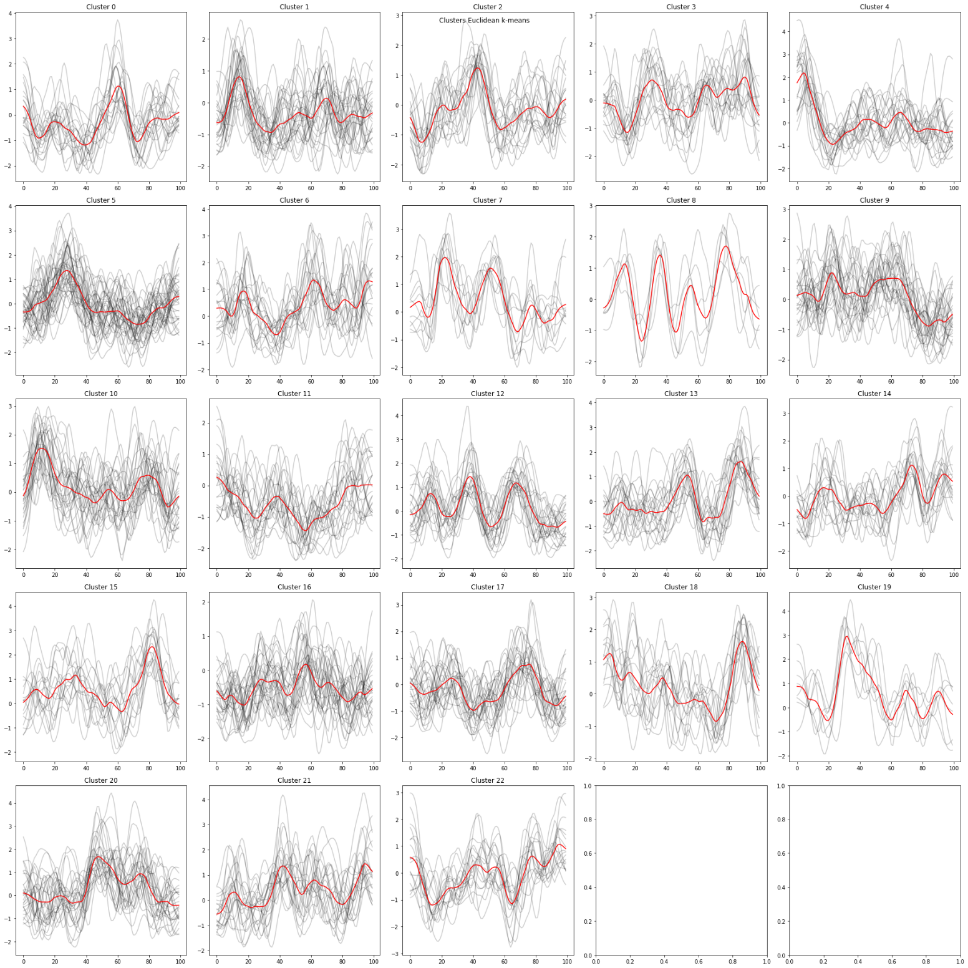

1. K-means clustering with DTW metric, full results

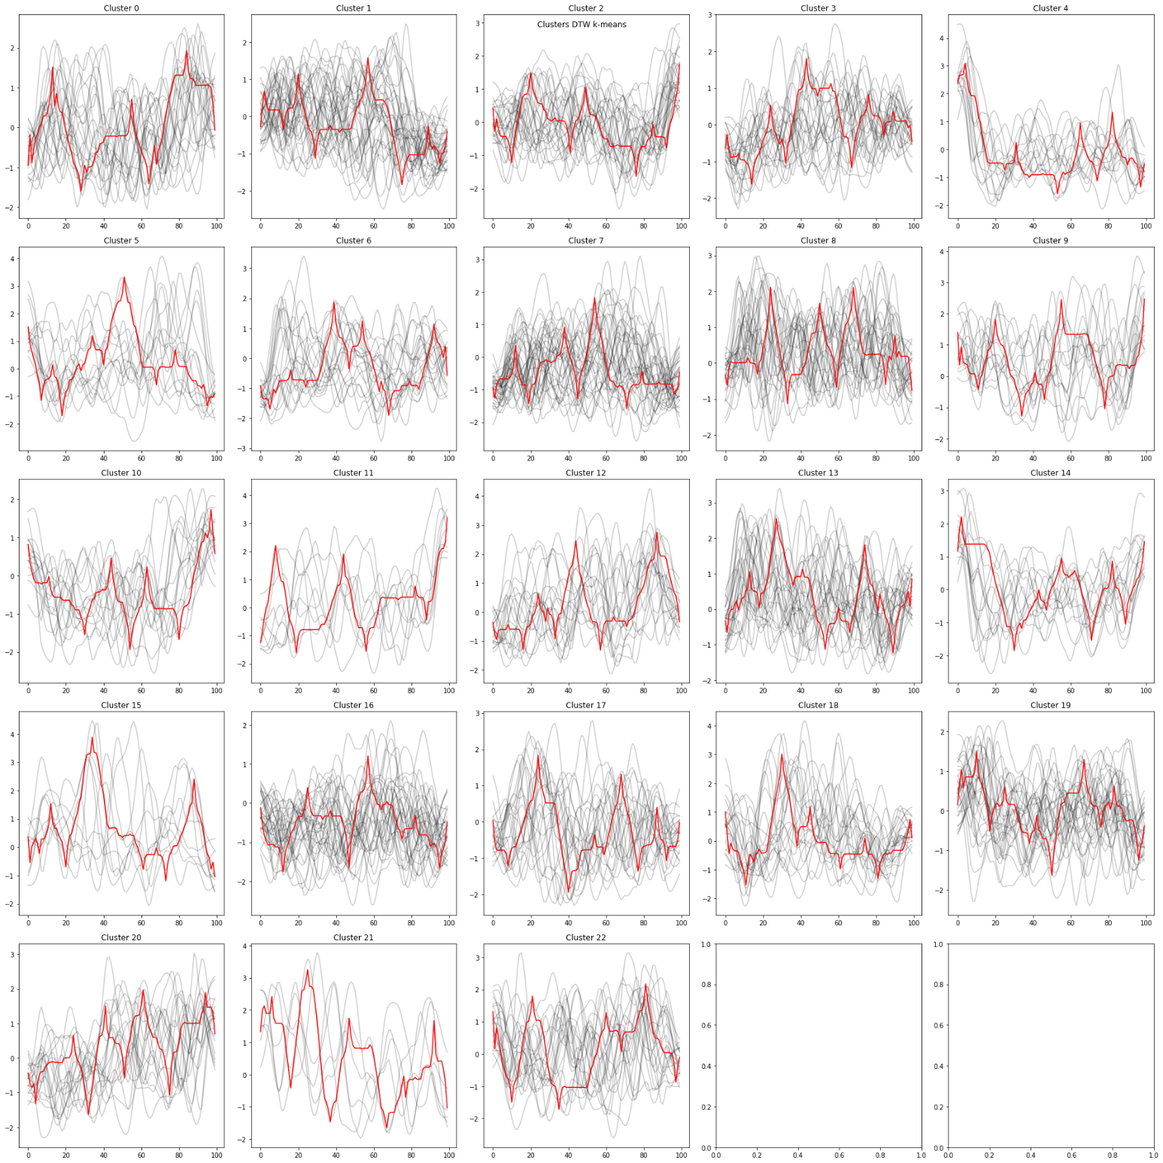

1. K-means clustering with Soft-DTW metric

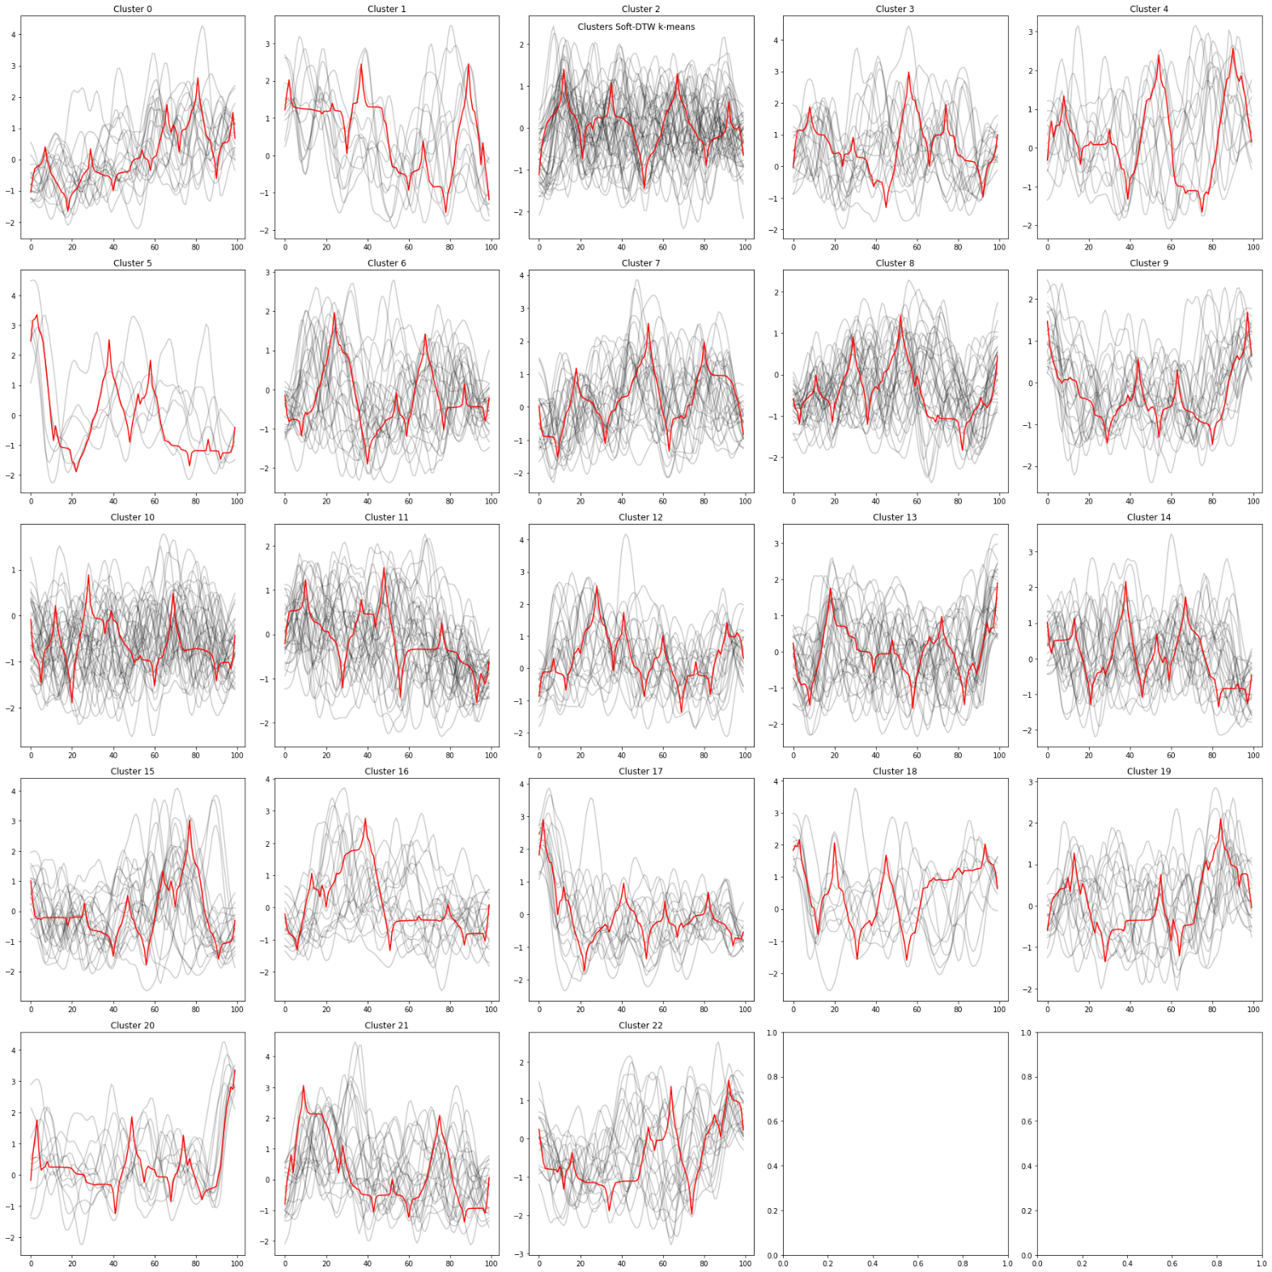

1. K-means clustering data with PCA implemented (Euclidean metric)

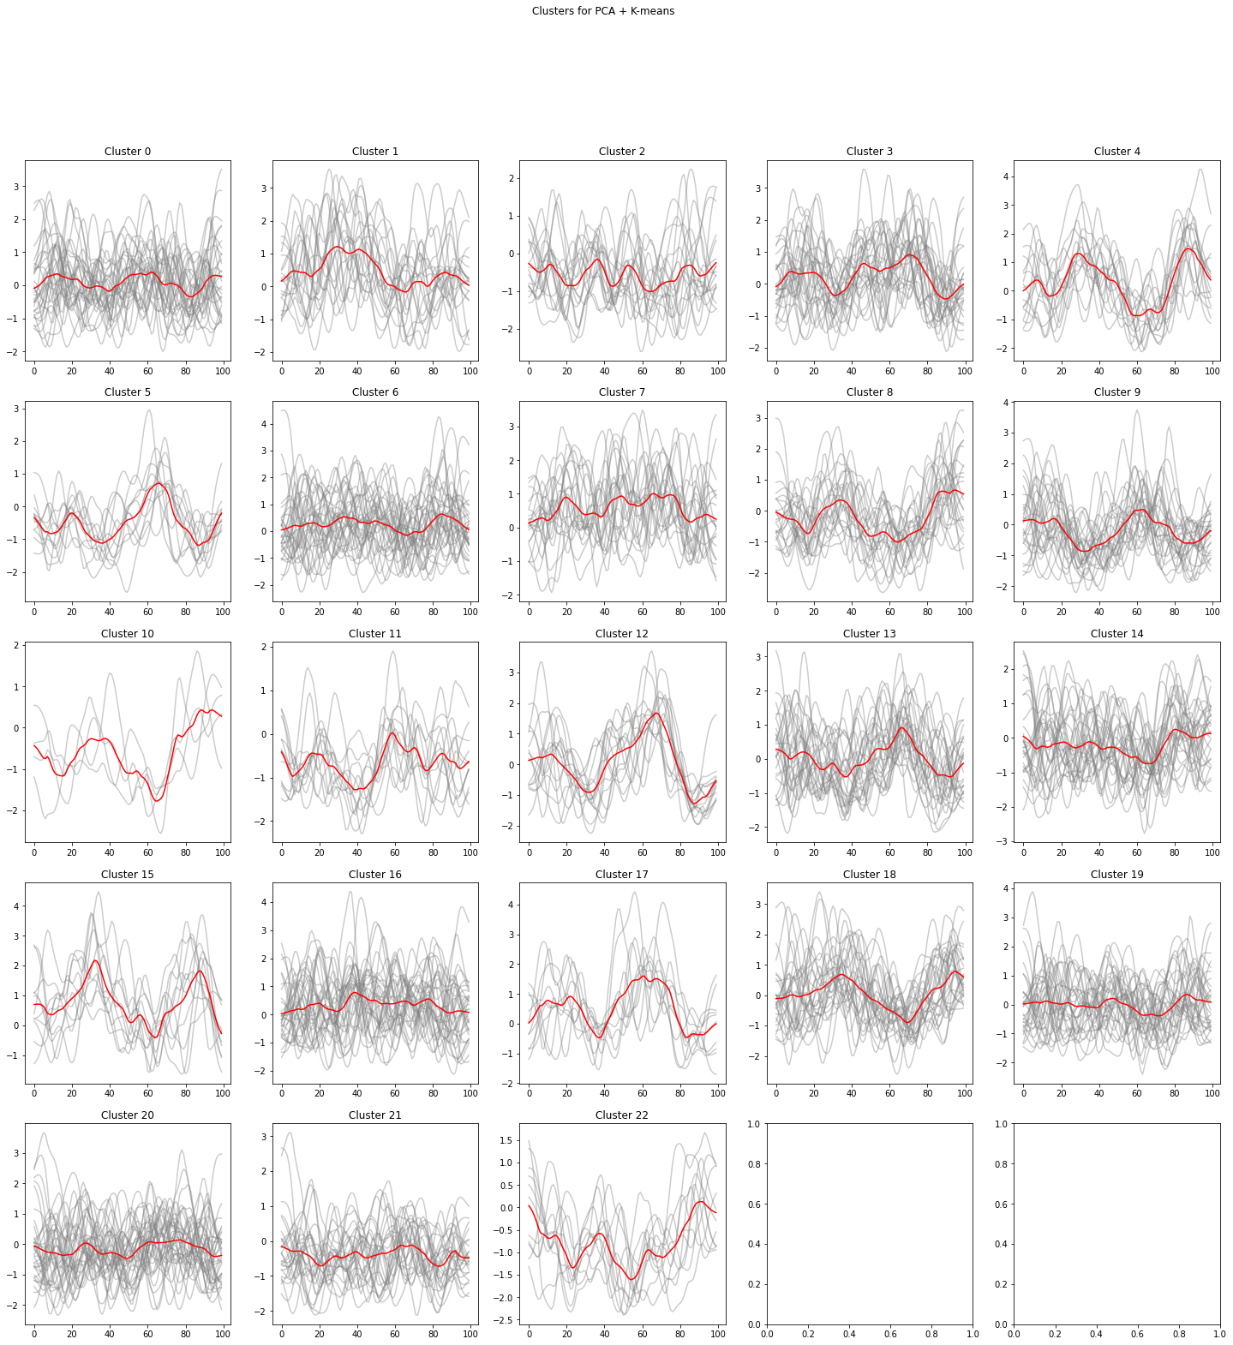

1. PCA + DBSCAN clustering

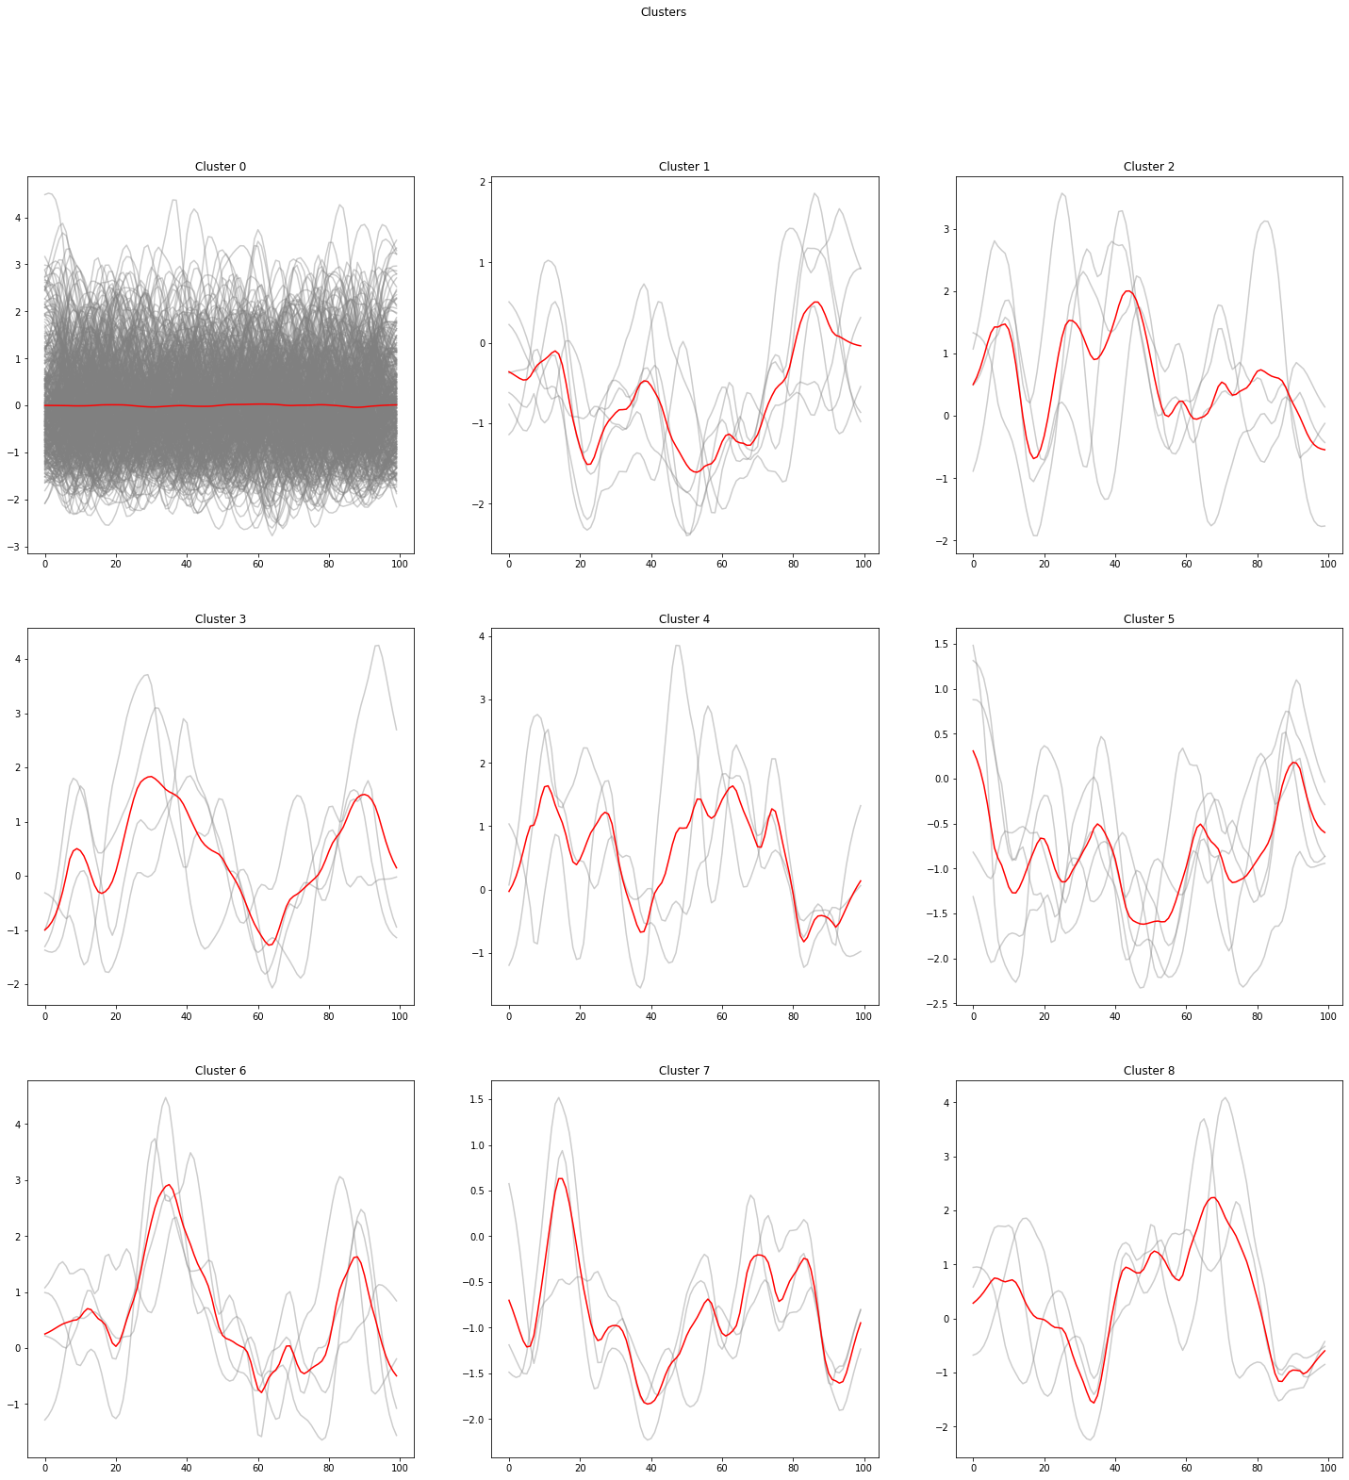

1. MiniSOM full clustering results

